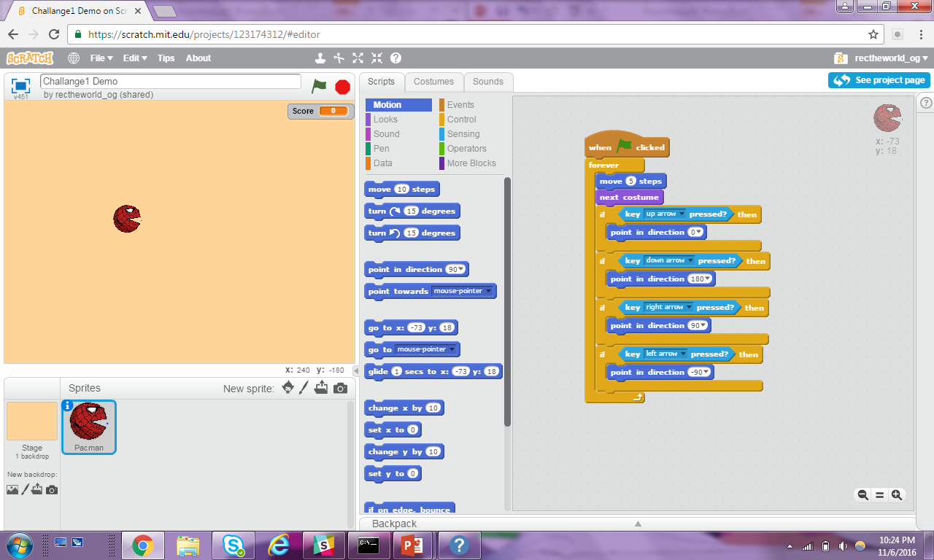

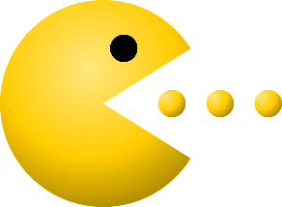

**Core Concept**: User Interface

User interface is how a player interacts with a Game

1

When **START** is Pressed

**WHILE** the Game is Playing

**MOVE** PacMan

**ANIMATE** PacMan

**IF** the **UP ARROW** is pressed

Point PacMan UP*

*Repeat for

**DOWN ARROW,**

**RIGHT ARROW**,

and **LEFT ARROW**

**CODE**

**STORY**